Development of control strategies for earthquakes reproduction on uniaxial shaking table

Desenvolvimento de estratégias de controlo para reprodução de sismos em plataforma sísmica uniaxial

Afonso Costa Henrique^{1,2} | Miguel Ayala Botto³ | Fernando Pires de Oliveira¹
¹LNEC – Laboratório Nacional de Engenharia Civil, Portugal ²IST – Instituto Superior Técnico, Portugal ³IDMEC, Instituto Superior Técnico, Universidade de Lisboa, Lisboa, Portugal

Abstract
Despite computational models used in earthquake simulations are becoming highly sophisticated and reliable, they still face limitations when complex, nonlinear, or poorly understood structural behaviours are considered. Experimental testing is thus an essential step for validation and calibration of these computational models. In fact, even advanced computational models that rely on machine learning techniques rely on experimental benchmarks to confirm their accuracy. Earthquake experimental testing remains thus indispensable for model validation, for understanding structural complex behaviours and eventually ensuring structural safety. This paper presents a control strategy for simulating a ground motion earthquake test applied to the uniaxial shaking table located at LNEC. The objective of the controller is to ensure that the shaking table reproduces the simulated earthquake signal as accurately as possible. The controller should guarantee that the earthquake signal affecting the uniaxial shaking table is insensible to feedback from the table’s vibration, thus replicating the true ground motion simulated earthquake. The performance of the computational model of the LNEC’s uniaxial shaking table is evaluated in terms of its frequency response spectra under three distinct control strategies: an iterative offline pseudo-adaptive open-loop controller with tests running in closed loop with a PI controller; a tuned PIDF controller; and an optimal controller. The results indicate that both the tuned PIDF and the optimal controllers offer superior performance in terms of response spectra compared to the iterative controller, whereas the optimal controller results in the best performance. The performance of the controllers depends on a reliable dynamic model identification of the uniaxial shaking table.

Keywords: Earthquake Engineering, Control Systems, System Identification, Closed-loop Identification

Resumo (fazer a retroversão para PT)
Na área científica da engenharia sísmica, apesar dos desenvolvimentos em simulação computacional, ainda se enfrentam limitações na modelação precisa de comportamentos estruturais complexos, não lineares ou outros pouco desenvolvidos. As simulações numéricas, mesmo com métodos avançados, requerem modelos experimentais para garantir uma boa precisão. Além disso, as abordagens de aprendizagem automática também dependem de dados experimentais para treinar e atualizar modelos. Os ensaios experimentais permitem por isso a validação e calibração desses modelos. Em resumo, os ensaios experimentais sísmicos continuam a ser indispensáveis para validar modelos, compreender comportamentos complexos e garantir a segurança estrutural. Neste artigo, um modelo computacional da plataforma sísmica uniaxial do LNEC é utilizado para comparar o desempenho, em termos de espetro de resposta, de três estratégias de controlo distintas: o método iterativo atualmente utilizado, que consiste num controlo pseudo-adaptativo offline em anel aberto e com o ensaio a decorrer em anel fechado com um controlador PI, um controlador PIDF sintonizado, e controlo ótimo. Os resultados indicam que ambos os controladores PIDF e o controlo ótimo oferecem desempenho superior em termos de espectros de resposta quando comparados com o método iterativo, sendo o controlo ótimo o método com o melhor desempenho em todas as simulações. No entanto, o desempenho de cada método depende da precisão da identificação do sistema, e deve ser avaliada a sensibilidade de cada método a este fator.
Palavras-chave: Engenharia Sísmica, Controlo de Sistemas, Identificação de Sistemas, Identificação em Anel Fechado

1- Introduction
The current uniaxial shaking table located at the LNEC consists of ,…. Descrever a mesa.
The n iteratively synthesizing a drive signal, distinct from the reference signal, such that the shaking table replicates the response spectra of the reference signal, i.e. the earthquake ground motion. At the end of each test, the system's performance is evaluated by comparing the response spectrum of the reference signal with that of the output signal measured on the platform. However, it is not always possible to achieve satisfactory performance with the command signal synthesized initially, and it may be necessary to generate more than one drive signal and carry out additional tests at the same amplitude. This procedure, although necessary in some situations, should be avoided as it induces additional damage to the structure.

2- Objectives
The objective of this work is to implement a controller, or strategy, to ensure that the shaking table reproduces the earthquake signal (reference/earthquake) as accurately as possible.

3- Control Strategies: Performance in simulation environment
Two control strategies, PIDF and the optimal controller, are being evaluated as a better approach to reproduce the earthquake ground motion on the shaking table. The results of numerical simulations show the superiority of these strategies (Fig. 1).
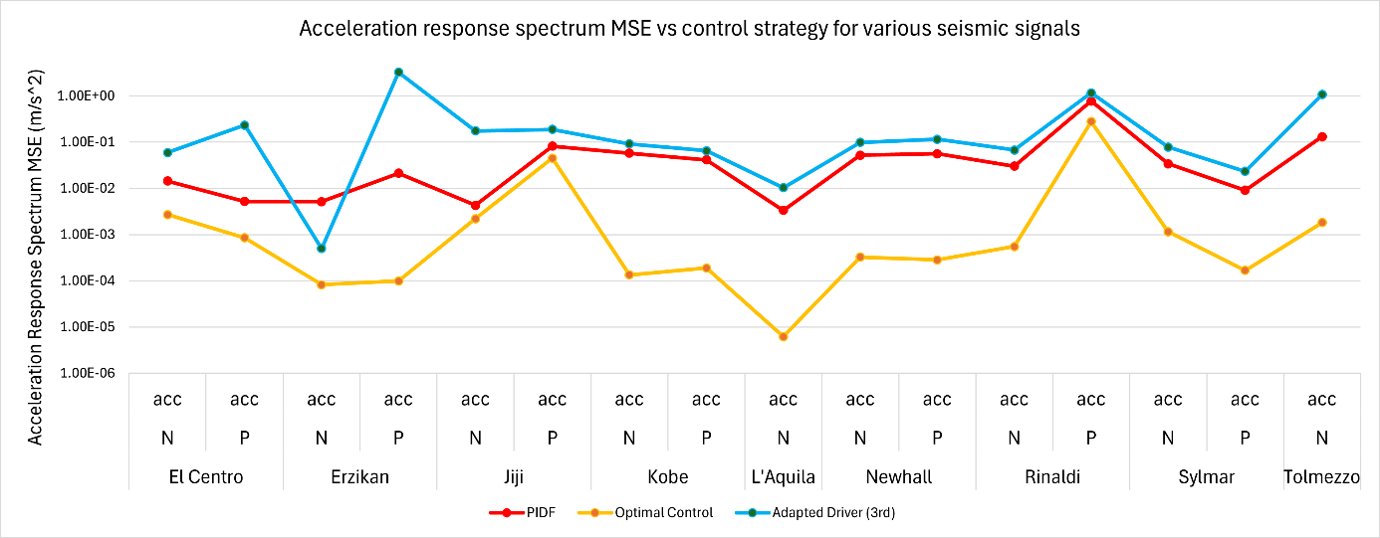
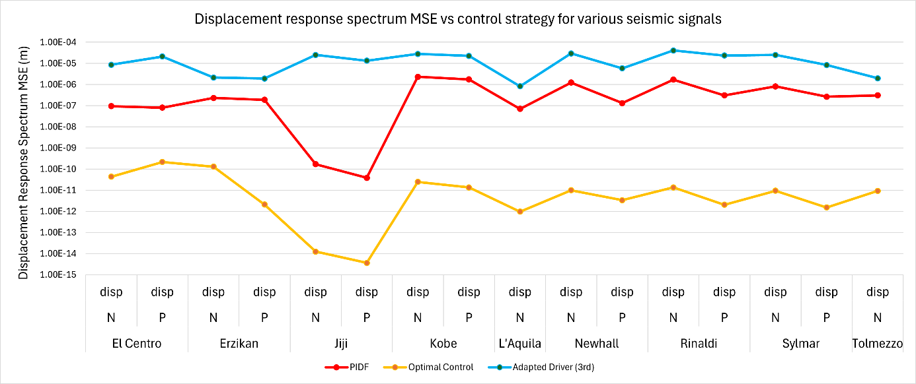
Fig. 1 | Accel. & Disp. response MSE under different earthquake signals for each control strategy.

4- Conclusions
The results indicate that the proposed controllers offer superior performance in terms of response spectra compared to the iterative method, while also requiring less user intervention in the process, with the optimal control strategy providing the best results in every instance. However, the performance of each method relies on accurate system identification, and the sensitivity of each method to this factor requires further investigation.

